Circuits Lab – Week 7
This lab has two parts. In Part 1 you will use a circuit simulator to explore how resistors and capacitors
behave in circuits. In Part 2 you will build your first real circuits on a breadboard using the Raspberry Pi
as a power supply. Record all measurements and observations as you go.

Part 1: Simulated Circuits

1. Resistors in series
- Build a circuit with a 10V voltage source and two resistors in series
Completed
- Define nodes on either side of the voltage source and in between the resistors
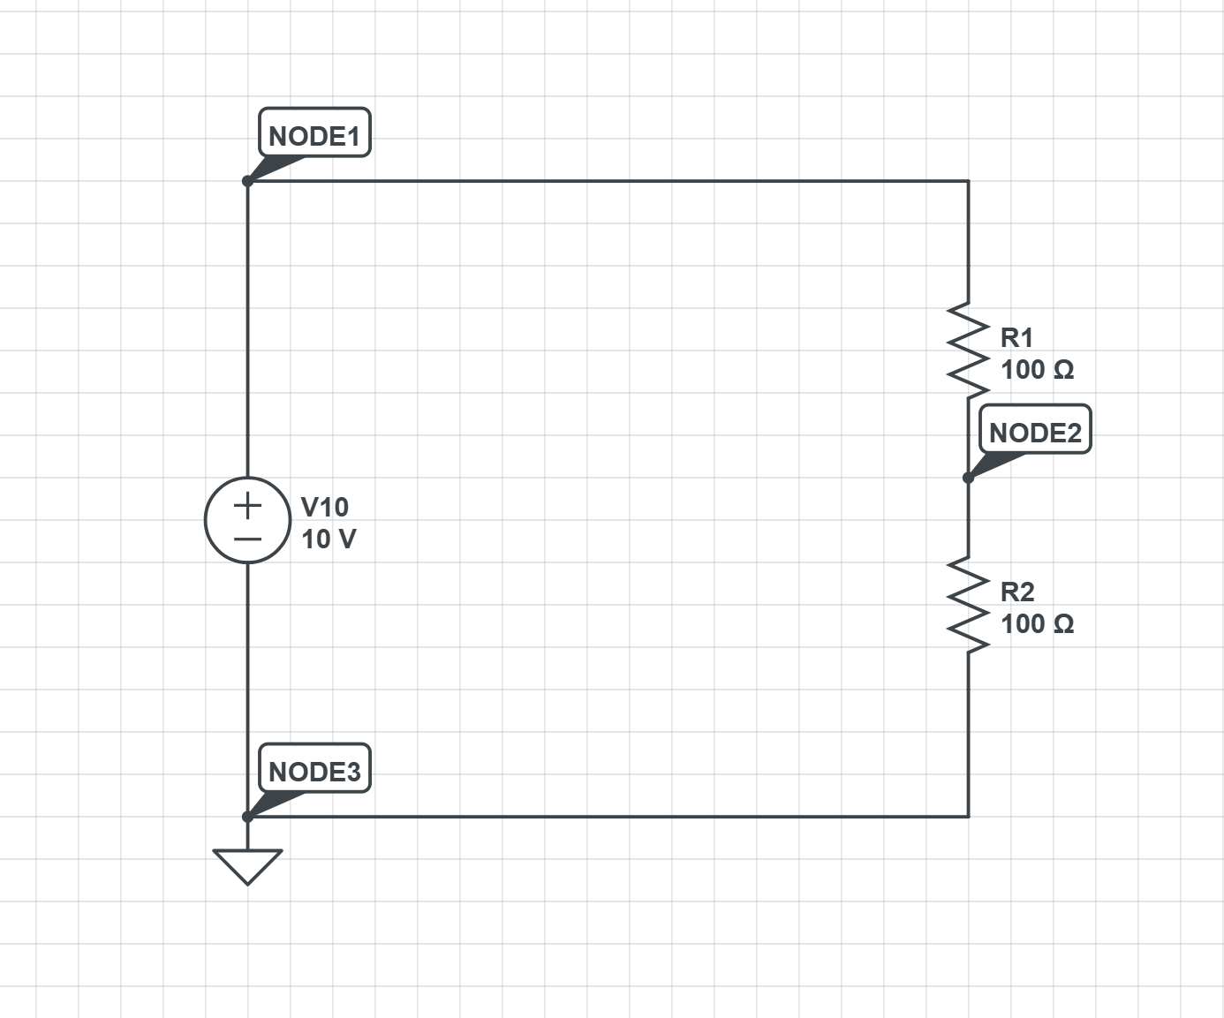
- Examine the voltage values at each node and the current for the system

Node # | Voltage Value | Current Value
1 (by the positive output of the voltage source) | 10V | 50.00mA
2 (between the two resistors) | 5V | Current in(resistor 1): 50.00mA  Current out(resistor 1): -50.00mA  Current in(resistor 2): 50.00mA  Current out(resistor 2): -50.00mA
3 (by the negative output of the voltage source) | 0V | 50.00mA

- Add a third resistor and an additional node and make note of how this changes the voltage at each node and the current in the system.
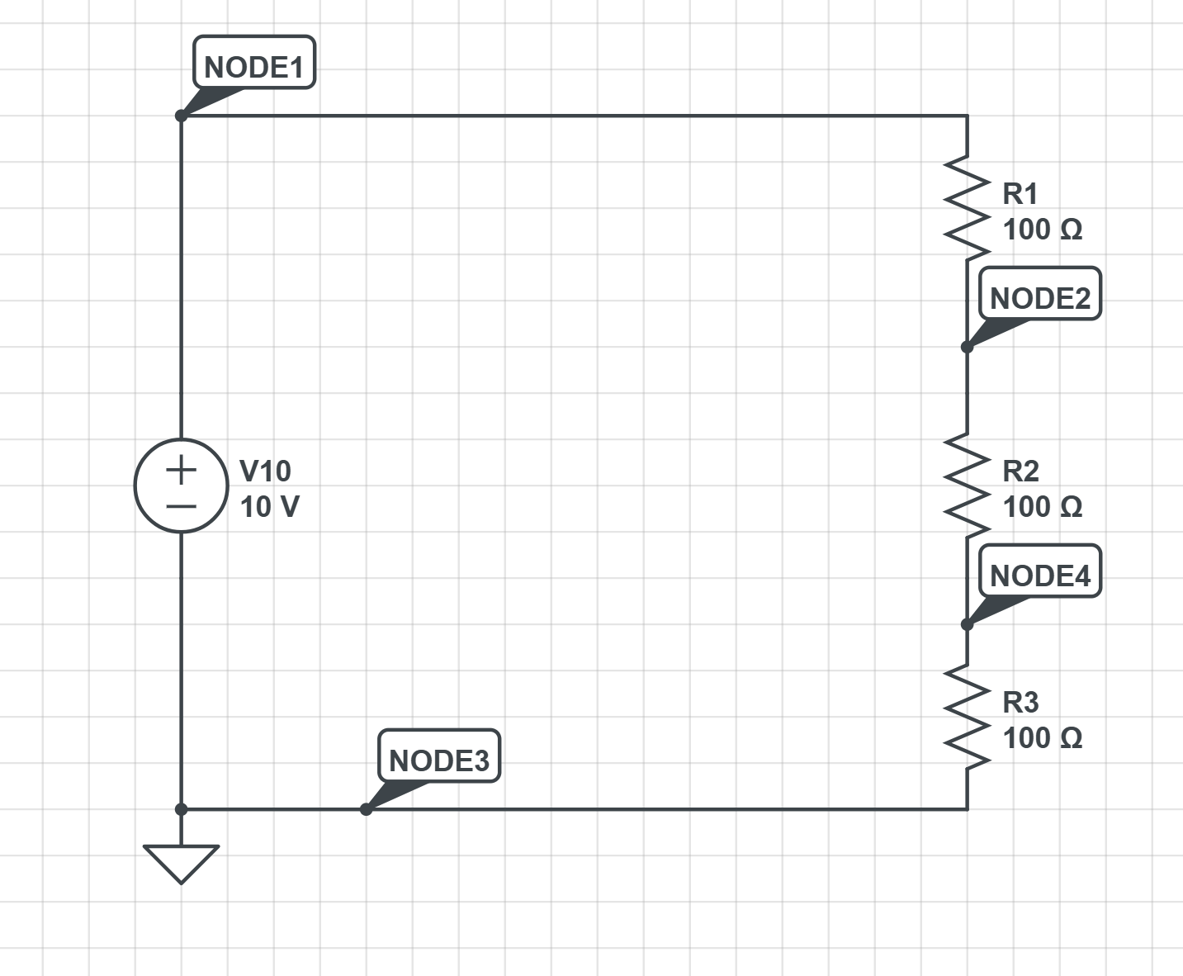

Node # | Voltage Value | Current Value
1 (by the positive output of the voltage source) | 10V | -33.33mA
2 (between the first two resistors) | 6.667V | Current in(resistor 1): 33.33mA  Current out(resistor 1): -33.33mA  Current in(resistor 2): 33.33mA  Current out(resistor 2): -33.33mA
3 (between the last two resistors) | 3.333V | Current in(resistor 3): 33.33mA  Current out(resistor 3): -33.33mA
4 (by the negative output of the voltage source) | 0V | 33.33mA

2. Resistors in parallel
- Build a circuit with a 10V voltage source and two resistors in parallel
Completed
- Define nodes on either side of the voltage source and each resistor

- Examine the voltage values at each node and the current across the voltage source and each resistor
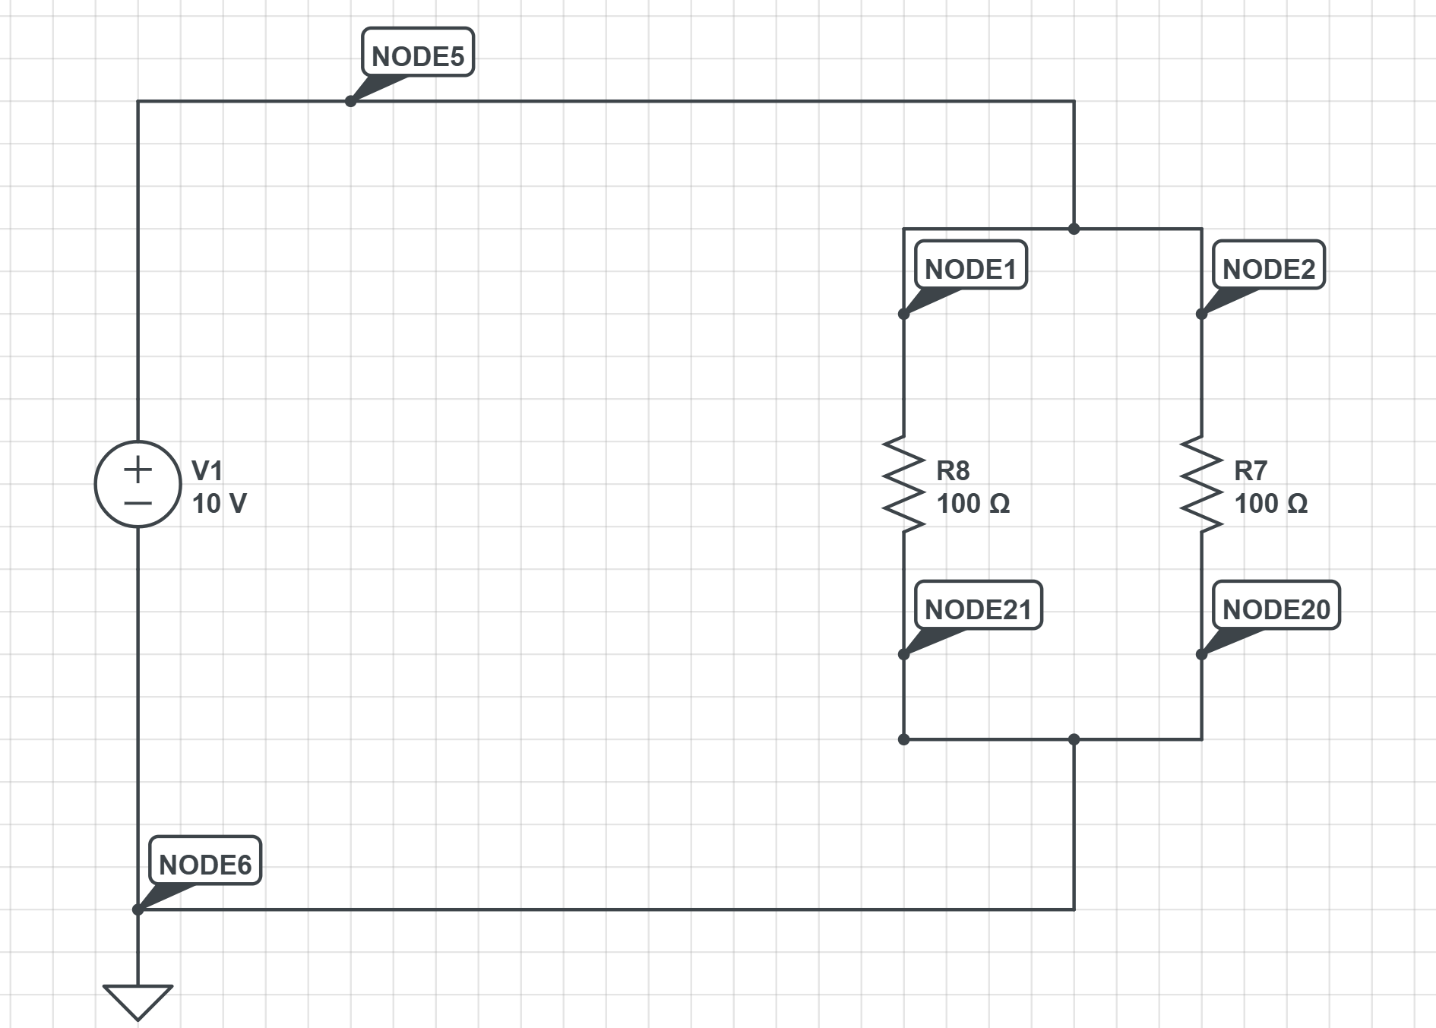
Node # (positions depicted above) | Voltage | Current
1 (across R8) | 10.00V | 100.0mA
2 (across R7) | 10.00V | 100.0mA
3 (across R8) | 10.00V | -100.0mA
4 (across R7) | 10.00V | -100.0mA
5 (across V1) | 10.00V | -200.0mA
6 (across V1) | 10.00V | 200.0mA

- Add a third resistor in parallel and additional nodes. Make note of how this changes the voltage at each node and the current across each resistor.
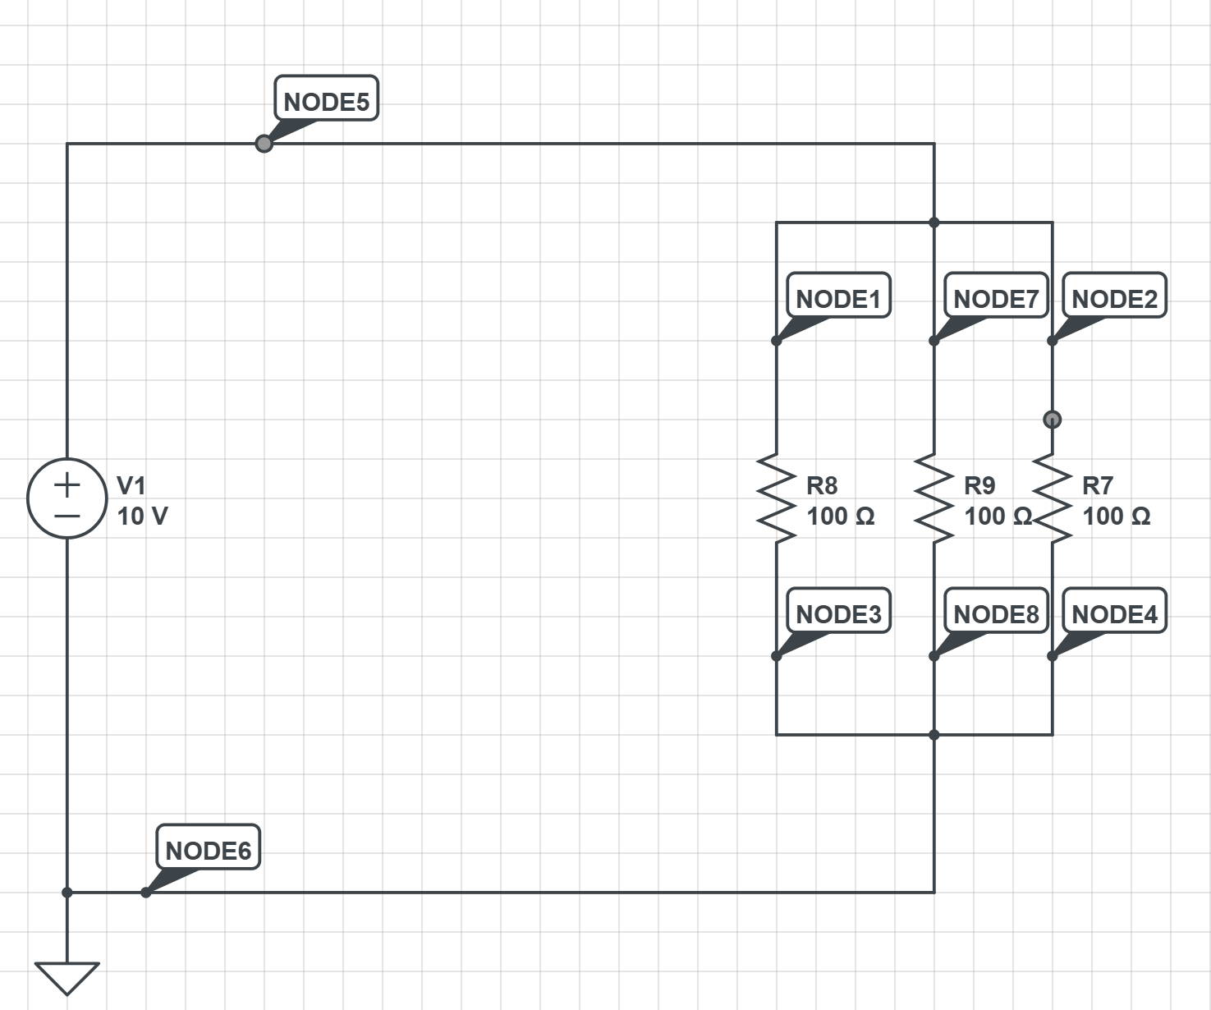
Node # (positions depicted above) | Voltage | Current
1 (across R8) | 10.00V | 100.0mA
2 (across R7) | 10.00V | 100.0mA
3 (across R8) | 10.00V | -100.0mA
4 (across R7) | 10.00V | -100.0mA
5 (across V1) | 10.00V | -300.0mA
6 (across V1) | 10.00V | 300.0mA
7 (across R9) | 10.00V | 100.0mA
8 (across R9) | 10.00V | -100.0mA

3. Resistors in series and parallel
- Build a circuit with a 10V voltage source with two resistors in parallel and a third resistor in series – the third resistor is in series with each parallel resistor in a single loop.
Completed
- Define nodes on either side of the voltage source and across each of the resistors
Completed
- Examine the voltage value at each node and the current across the voltage source and each resistor. Make note of how this compares to either the case of resistors only in parallel or only in series.
All of the voltage and current values across the resistors and the voltage source are labeled accordingly.
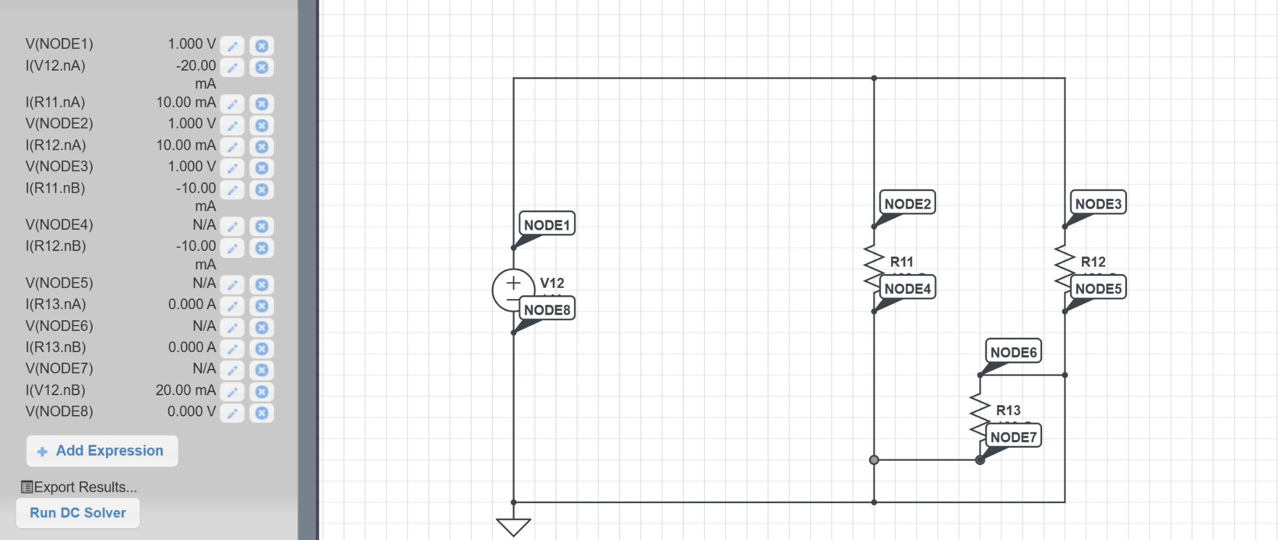

4. RC circuit
An RC circuit combines a resistor and a capacitor. The capacitor stores energy (like a tiny rechargeable
battery), and the resistor controls how quickly it charges and discharges. The "time constant" of the
circuit, written as the Greek letter tau (τ), is just the resistance multiplied by the capacitance: τ = R × C.
This tells you roughly how long it takes for the capacitor to charge up or drain.
- Build a simple RC circuit with a step function voltage supply, a 100 Ohm resistor and 10uF capacitor. Add voltage in and out nodes on either side of the resistor.
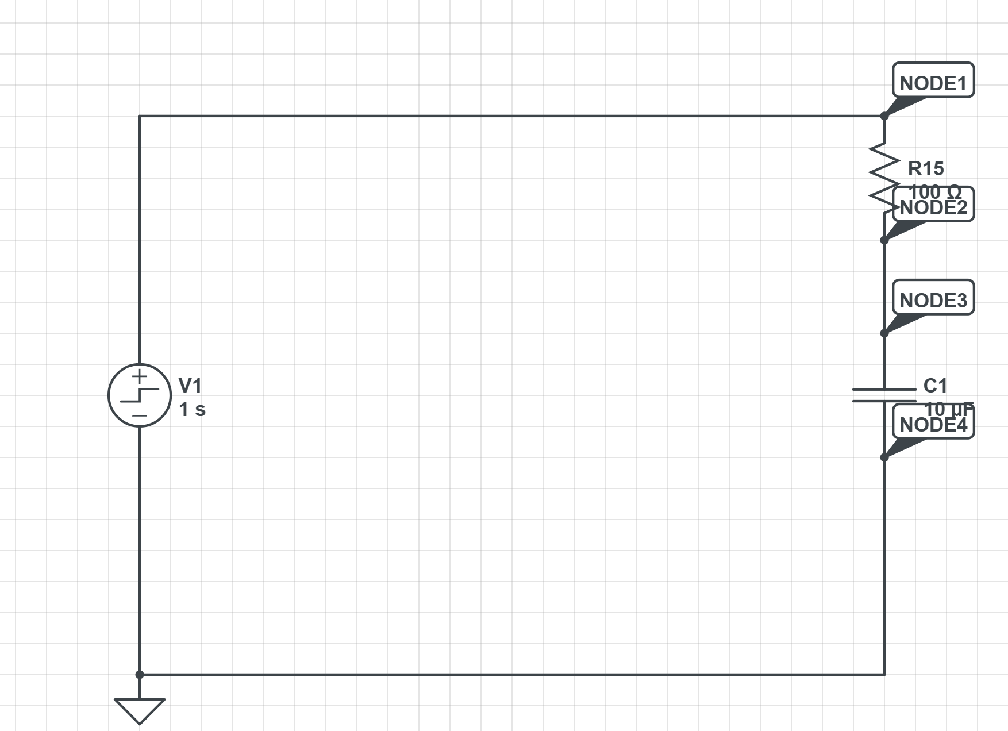
- Use the time domain simulator to examine how the voltage and current change over time.
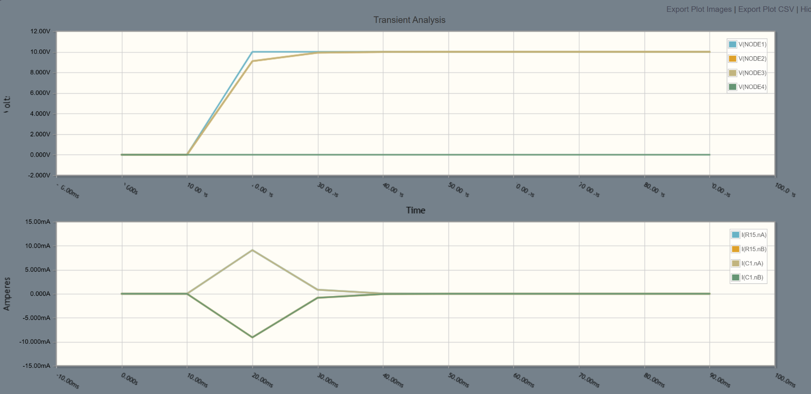
- Explore how the time dependence of the system changes as you vary the resistance and capacitance in the system.
  - The time dependence increases as the resistance and capacitance increase.
- Calculate the time constant (τ = R × C) for each combination you try. Does the simulator match your calculation?

Resistance | Charge | Time Constant
100 Ohms | 10 microF | 0.001 seconds
69 Ohms | 67 microF | 0.005 seconds
200 Ohms | 70 microF | 0.014 seconds
1 Ohm | 1 microF | 0.000001 seconds
300 Ohms | 45 microF | 0.0135 seconds

The larger the time constant becomes, the smoother our voltage and current curves become.

5. RC filter (low-pass filter)
An RC circuit can also be used as a filter. When you feed a changing signal into an RC circuit, it lets slow
changes through but smooths out fast changes. This is called a "low-pass filter" because it passes low
frequencies and blocks high ones. The frequency where it starts to block is called the "cutoff frequency"
and is determined by the same time constant from the previous acti*-vity. This is an important concept –
you will need this idea in a few weeks when we power a radiation detector and need to filter out noise
from the power supply.
- Build a circuit with an oscillating square wave voltage supply, initially with a 100 Hz frequency.
Include a 1kΩ resistor and a 1uF capacitor. Add nodes to examine the input and output voltage.
Completed
- Use the time domain simulator to examine how changes to the resistance (and/or capacitance)
affect the output voltage. Try different input voltage frequencies.
The output voltage decreases in size, resulting in a smaller square shape along with a less steep curve.
- What happens to the output when you increase the frequency of the input signal? What
happens when you decrease it?
The square shape of the voltage is not conserved.
d. At what point does the output start to look very different from the input? How does this relate
to the time constant of your circuit?
The larger the numbers get, the more distorted the graphs become. This relates to the increasing time constant of our circuit as resistance and and charge are increasing.
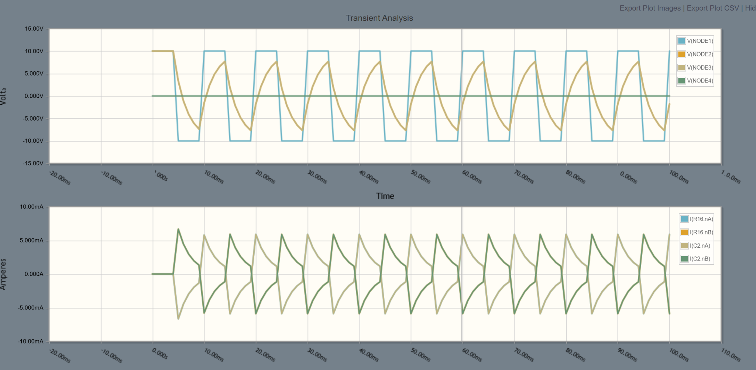

Part 2: Building Real Circuits
Now you will build real circuits on a breadboard using your Raspberry Pi (RPi) as a voltage source. This
will get you familiar with the breadboard and basic tools you will use in the coming weeks.

6. Setting up your breadboard
- Turn on the Raspberry Pi (RPi)
  - Completed
- The breadboard has two long columns on each side marked + and –. These are the power rails. The rows in the middle of the board are where you will place components. Each row of five holes is connected internally, so anything plugged into the same row is electrically connected.
  - Completed
- Connect one of the 5V pins on the RPi to the + column on the breadboard
  - Completed
- Connect one of the ground pins on the RPi to the – column on the breadboard
  - Completed
- Run a connector from the + column to one row on the main part of the breadboard
  - Completed
- Run a connector from the – column to a different (but close) row on the main part of the breadboard
  - Completed
- If we connected a 1Ω resistor (don’t try it!) between these two rows – so that it is in a closed loop with the 5V supply from the RPi, how much current would this circuit attempt to draw across the resistor?
  - This circuit would attempt to draw 5 Amps of current.
- The RPi adaptor provides 5V and up to 2 Amps, is this current sufficient?
  - More than sufficient, it would provide too many amps of current.
- What do you think might happen? Please don’t actually do this.
  - I believe that our circuit would short-circuit.
- Connect a resistor of more than at least 500Ω between the two rows to make a complete circuit.
  - Completed.
- Why is a higher resistance safer? What might happen to the resistor if it draws too much current?
  - A higher resistance is safer as it ensures a smaller current is drawn. I believe a resistor will stop working (burn out) if it draws too much current.
- Use your multi-meter to measure the voltage drop across the resistor. Is it what you expected? NOTE: To measure voltage, connect the meter leads to the two sides of the component (in parallel with it). To measure current, you have to put the meter in series with the rest of the circuit – the current has to run through the meter. If your meter can measure current, try that as well.
  - It is what we expected.

7. Building a real RC circuit
Now you are going to build a real version of the RC circuit you simulated in Part 1 and actually measure
the time constant.
- Remove the single resistor from your breadboard circuit and replace it with a 10kΩ resistor and a 100uF capacitor in series. The resistor should connect to the +5V side and the capacitor should connect between the resistor and ground. Make sure the capacitor is oriented correctly – electrolytic capacitors (the tall cylindrical ones) have a marked negative side that should connect toward ground.
Completed
NOTE: The order of resistor and capacitor in the loop does not change the time constant, but
placing the resistor first and measuring voltage across the capacitor makes it easier to see the
charging and discharging behavior.
- Calculate the time constant for this circuit. With a 10kΩ resistor and a 100uF capacitor, what
should τ be? This should be a familiar unit of time.
τ = 10000Ω * 0.0001F = 1s
- Set your multi-meter to measure DC voltage and connect it across the capacitor (one lead on each side of the capacitor).
Completed
- Disconnect the wire going from the + rail to the resistor. The capacitor should be fully discharged – the voltage across it should read 0V (or close to it). If it does not, briefly touch a connecting wire across the resistor+capacitor circuit, with the + rail disconnected, to discharge it.
Completed
- Now reconnect the wire from the + rail to the resistor and watch the voltage on the multi-meter. You should see the voltage rise from 0V toward 5V. Does it rise quickly at first and then slow down?
Completed
- Once the capacitor is charged, disconnect the +5V wire from the resistor and instead connect that end of the resistor directly to the ground (–) rail. Watch the voltage reading. You should see it decay from ~5V back toward 0V.
Completed

- Try to estimate how long it takes for the voltage to drop to about 37% of where it started (roughly 1.8V if it started at 5V). This time is one time constant. How does it compare to your calculation?
Completed, it does compare to our calculation, but it is slightly higher than our calculation given that the capacitor was charged to roughly 5.050V.

NOTE: 37% might seem like an odd number. It comes from the math behind the exponential
decay – after exactly one time constant, the voltage has dropped to 1/e (about 37%) of its
starting value. This is the same exponential behavior you saw in the simulation.
- Try swapping in different resistor and capacitor values. For each combination, calculate the
expected time constant first, then measure it. Try to pick values that give you time constants
you can comfortably observe – too short and it will be hard to read the meter, too long and you
will be waiting a while.
Completed. The second resistor that was used was 4.7uF and the time constant calculated 0.47s, and the capacitor seemed to charge roughly that fast.

- How do your measurements compare to the values you calculated and to what you saw in the
simulation? Are they exactly the same? If not, what might be causing any differences?
We can them use these results to determine that as the capacitance goes up or as resistance goes up, the time it takes for the capacitor to charge will also increase. The times that were recorded during the experiment were not exactly the same as the predicted times, and this could be because the voltmeter has some resistance as well, so the total resistance in the loop is actually greater than the resistance value of the resistor.

